Output:

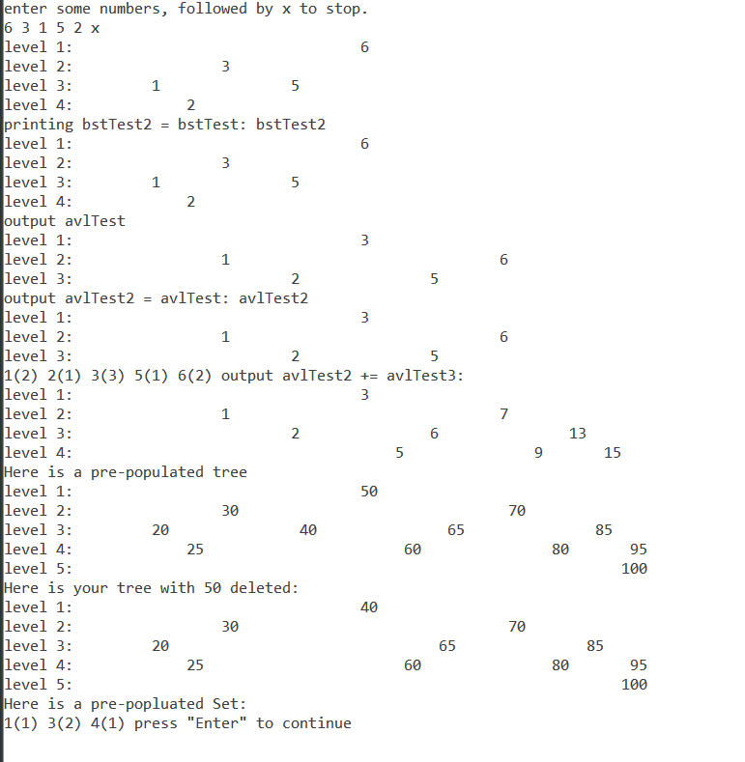

Test Plan:

I was not able to get multiple rotations accomplished. I also did not finish Set.h – these are the failed tests listed below.

